

**BoM Import Utility**

**Revision**

**Revision History**

|  |  |  |  |  |
| --- | --- | --- | --- | --- |
| **Date** | **Revision** | **Description** | **Signature / Date** | |
| 04/15/22 | 1 | Initial draft of BoM Import Utility User Guide explains the steps to Install and Use BoM Import Utility | Prepared | Arshad Mahmood |
|  |  | Verified |  |
|  |  | Approved |  |
| mm/dd/yy |  |  | Prepared |  |
|  |  | Verified |  |
|  |  | Approved |  |
| mm/dd/yy |  |  | Prepared |  |
|  |  | Verified |  |
|  |  | Approved |  |
| mm/dd/yy |  |  | Prepared |  |
|  |  | Verified |  |
|  |  | Approved |  |

Table of Contents

1 Introduction 6

1.1 Purpose 6

1.2 Scope 6

1.3 Abbreviations, Definitions and Acronyms 7

2 CBoM Import Utility Installation 8

2.1 BoM Import Utility Operation 12

2.1.1 Export Reference Files from MS Dynamics 365 13

2.1.2 Generate Data Files 14

2.1.2.1 CBoM Files 15

2.1.2.2 VT Inventory Files 20

2.1.2.3 Jabil Inventory Files 20

2.1.2.4 Agile BoM 21

2.1.2.5 Solidworks BoM 22

2.1.2.6 Write New Parts 22

2.1.2.7 Part Change Detection 22

2.1.2.8 Import Trade Agreement Journal and Category Assignment 23

2.1.2.9 Import Approved Vendor List 23

List of Figures

Figure 1. BoM Import Utility GUI 6

Figure 2. BoM Import Utility Setup Files 8

Figure 3. BoM Import Utility Setup Welcome Screen 8

Figure 4. BoM Import Utility Setup Install Folder 9

Figure 5. BoM Import Utility Change Install Folder 10

Figure 6. BoM Import Utility Select Install Folder 10

Figure 7. BoM Import Utility Installation Complete 11

Figure 8. BoM Import Utility Desktop Shortcut 11

Figure 9. BoM Import Utility Start Menu Shortcut 11

Figure 10. BoM Import Utility 12

Figure 11. BoM Import Utility Files Directory 12

Figure 12. Export Reference Files 13

Figure 13. Export in batch Process 14

Figure 14. Wait for Export Process 14

Figure 15. Export Process Completion 14

Figure 16. BoM Import Utility File Selection 15

Figure 17. Select Import Project in D365 16

Figure 18. Add Upload Files Package 17

Figure 19. Wait for Import Completion 17

Figure 20. Import Process Completion 17

Figure 21. Import Released Product V2 18

Figure 22. Upload Released Product V2 File 18

Figure 23. Activate BoM Version 19

Figure 24. Activate BoM version process 19

Figure 25. Inventory Import Files Project 20

Figure 26. BoM Import Utility Options 21

Figure 27. Files Import Completion 21

Figure 28. Agile BoM Before Processing 22

Figure 29. Agile BoM After Processing 22

Figure 30. Solidworks BoM Before Processing 22

Figure 31. Solidworks BoM After Processing 22

Figure 32. Trade Agreement Journal Import 23

Figure 33. Approved Vendor List Project 23

List of Tables

Table 1‑1 Abbreviations, Definitions and Acronyms 7

**BoM Import Utility -**

# Introduction

BoM Import Utility is developed to import Venturetronics data to the MS Dynamics 365 system. BoM Import Utility is used to generate Import data files for MS Dynamics 365 using Exported reference files and latest CBoM file. Generated files are uploaded to MS Dynamics 365 through Import Project to update Venturetronics data to the system. The BoM Import Utility supports multilevel file generation to fulfil different data update requirements. Simple CBoM option is to generate basic data update files. VT Inventory and Jabil Inventory options are provided to update Venturetronics and Jabil Inventories respectively.

BoM Import Utility can be used to add Parent-Child relationship in Solidworks and Agile BoMs. Support to write only newly added Parts and detect the changes occurred in already added parts, is also provided. The figure below shows the GUI of BoM Import Utility.

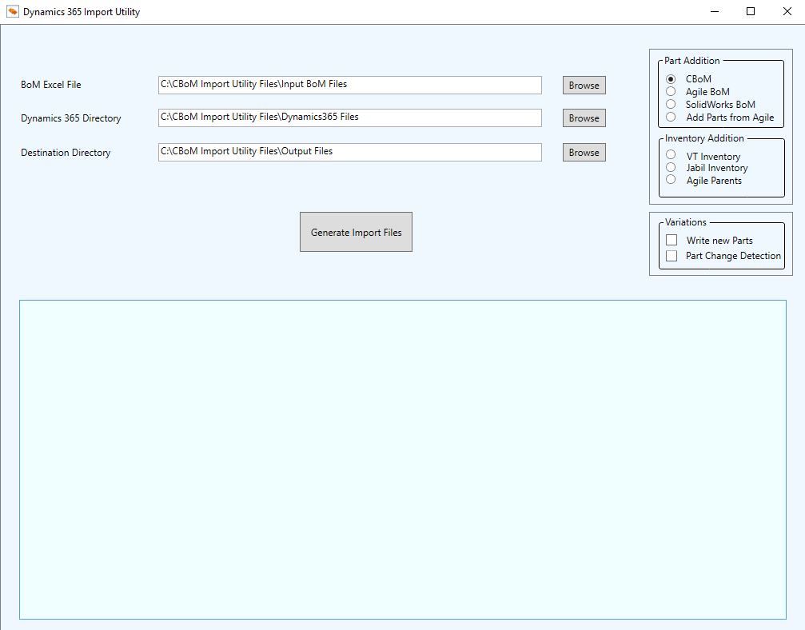

Figure . BoM Import Utility GUI

## Purpose

This document is made to provide step by step guidance to install and use BoM Import Utility.

## Scope

This document describes the steps involved in installation and usage of BoM Import Utility.

## Abbreviations, Definitions and Acronyms

|  |  |
| --- | --- |
| Acronyms | Definition |
| BoM | Bill of Material |
| MS | Microsoft |

Table ‑ Abbreviations, Definitions and Acronyms

# CBoM Import Utility Installation

Following steps are required to install BoM Import Utility to system

1. Open BoM Import Utility Setup folder

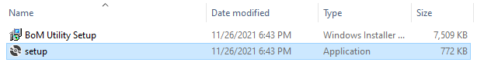

Figure . BoM Import Utility Setup Files

1. Double click Setup file, following Welcome screen will appear

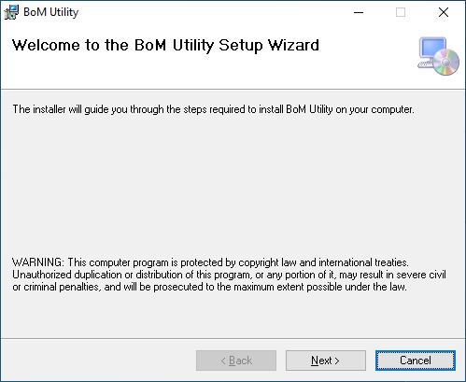

Figure . BoM Import Utility Setup Welcome Screen

1. Press “Next” button to proceed following Installation Folder selection screen

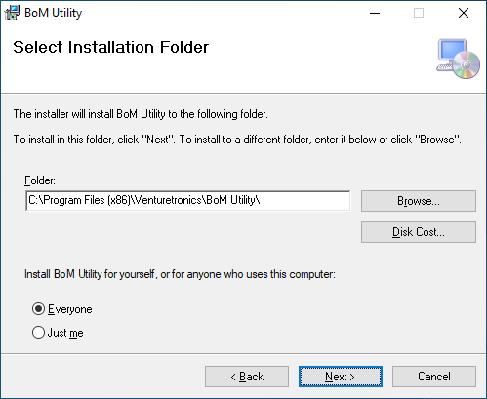

Figure . BoM Import Utility Setup Install Folder

1. If you want to keep the installation folder to default, press “Next” otherwise click on “Browse” button

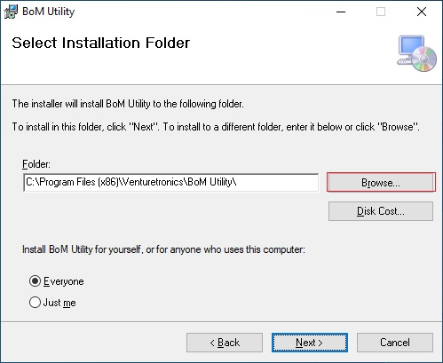

Figure . BoM Import Utility Change Install Folder

1. Select the Installation folder, click OK and then click “Next”

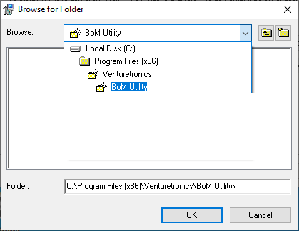

Figure . BoM Import Utility Select Install Folder

The BoM Import Utility installation begins, and files are copied to selected folder.

1. At the completion of installation following screen is shown. Click “Close” to mark end of installation.

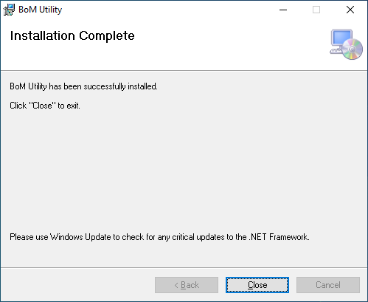

Figure . BoM Import Utility Installation Complete

1. After completion of installation process, BoM Import Utility shortcut is placed at Desktop

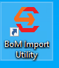

Figure . BoM Import Utility Desktop Shortcut

1. BoM Import Utility shortcut is also placed in Start Menu

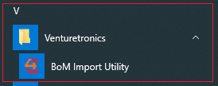

Figure . BoM Import Utility Start Menu Shortcut

1. Double click on any of BoM Import Utility shortcut and application’s GUI is shown



Figure . BoM Import Utility

## BoM Import Utility Operation

“CBoM Import Utility Files” directory is created in C: drive when application installation is complete. The directory contains three sub-directories as follows

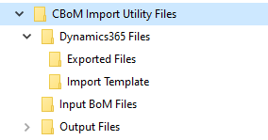

Figure . BoM Import Utility Files Directory

1. Dynamics365 Files (Exported files + Import Template)

This directory contains Exported files folder which contains reference files downloaded from MS Dynamics 365. Get the reference files and place these files in this folder. ‘Import Template’ folder includes the empty template files on which will be copied to Output folder and generated data will be inserted.

1. Input BoM Files

This folder contains the CBoM file for which data is required to be updated in MS Dynamics 365. Place the CBoM files in this folder and select the input file from here.

1. Output Files

Data files generated by Utility are placed here with respect to generation date to easily find the latest data files. Copy the data files folder to destination MS Dynamics 365 system to upload the files.

### Export Reference Files from MS Dynamics 365

To export Reference files from MS Dynamics 365, perform the following steps

Go to MS Dynamics 365 -> Data Management -> Export Projects -> Export-ImportTemplate

Click on “Load Project” as shown below

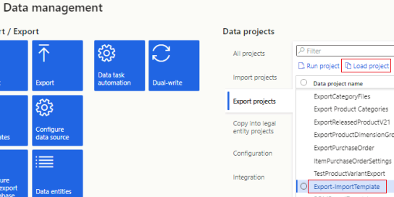

Figure . Export Reference Files

After the project is loaded click on “Export in batch” on Top-Left corner and wait for process to complete.

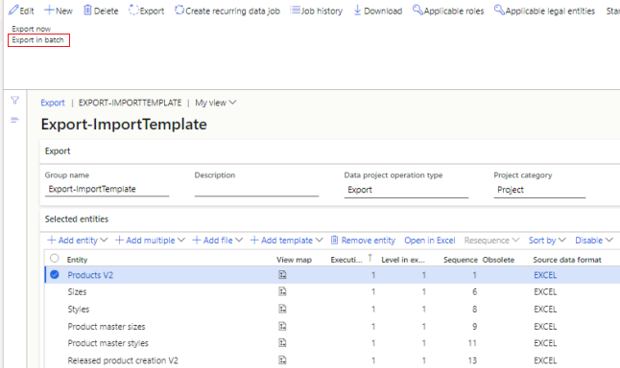

Figure . Export in batch Process

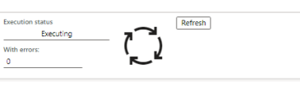

Figure . Wait for Export Process

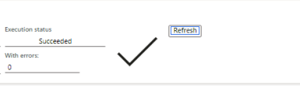

Figure . Export Process Completion

After completion of the Export process click on “Download” and copy the downloaded files to “Exported” (reference) files folder in “CBoM Import Utility Files\Dynamics365 Files\Exported Files”. Now BoM Utility has latest reference files.

### Generate Data Files

Start the BoM Import Utility from Desktop shortcut or Start Menu shortcut. Once the application is started select Input CBoM file using BoM Excel file text box and Browse button.

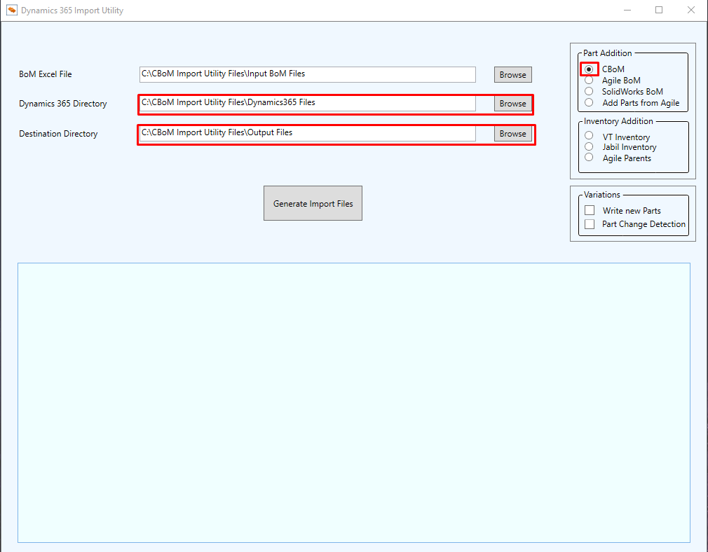

Figure . BoM Import Utility File Selection

The application by default creates “Dynamics 365 files” directory in C: drive which contains Template data files and Exported reference files. Place the updated reference files in respective folder or give the path to any other directory where both of Template and Reference files are placed.

“Output” files directory is created by default at the time of application installation and output files are placed in this folder. Change the output directory using Browse button if you want to place output files to directory other than default directory.

Following types of output files can be generated from input CBoM file.

#### CBoM Files

Using this option files related to Product Part update in MS Dynamics 365. Selecting the option generates following files

* Bill of materials headers and versions V3.xlsx
* Bill of materials headers.xlsx
* Bill of materials lines V3.xlsx
* Bill of materials versions V3.xlsx
* BoM Import Report.xlsx
* Product default order settings V3.xlsx
* Product master sizes.xlsx
* Product master styles.xlsx
* Product variants V2.xlsx
* Products V2.xlsx
* Released Products V2 - New Parts With Default Rev.xlsx
* Released product creation V2.xlsx
* Released product variants V2.xlsx
* Released products V2.xlsx
* Sizes.xlsx
* Styles.xlsx

The BoM Import Report.xlsx file contains the summary and detailed report of all the Parts added and removed from assemblies.

To upload these files to MS Dynamics 365, perform the following steps

Go to MS Dynamics 365 -> Data Management -> Import Project -> Import CBoM Files

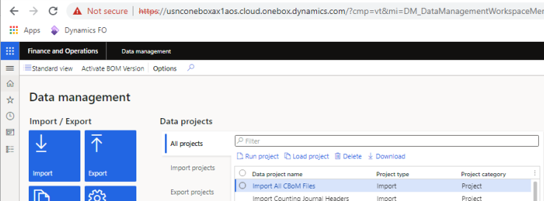

Figure . Select Import Project in D365

Open the “Import All CBoM Files” Project and click on “Add File”, select “Package” from “Source Data Format”. Click on “Upload and add” button and select the package, which was generated as “Step 1 - Import CBoM Files.zip” at the path specified for output. Now click on “Import in batch” in top-left corner, press OK on the popped-up dialog as shown in **Figure 18** and wait for process to complete as shown in **Figure 19**. Keep checking the process by pressing “Refresh” button. If the process successfully completes a Tick (✓ ) mark is displayed as shown in **Figure 20**. Now check the Inventory On-Hand list and verify that Inventory is updated.

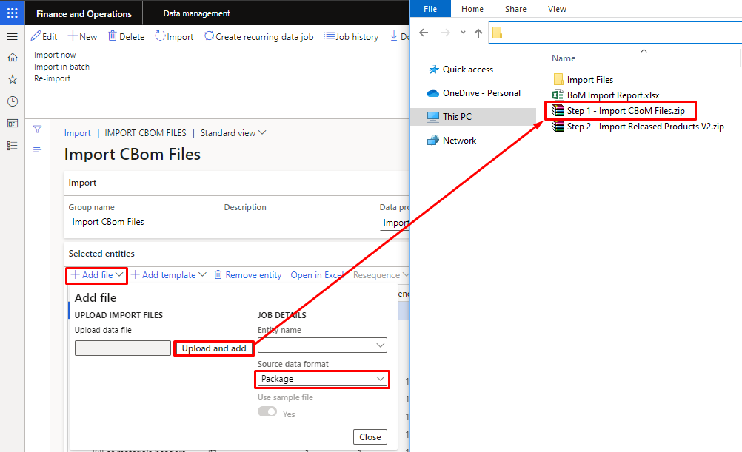

Figure . Add Upload Files Package



Figure . Wait for Import Completion



Figure . Import Process Completion

After Import process completion, go to the “ImportReleasedproductV2Only” project as shown in figure:

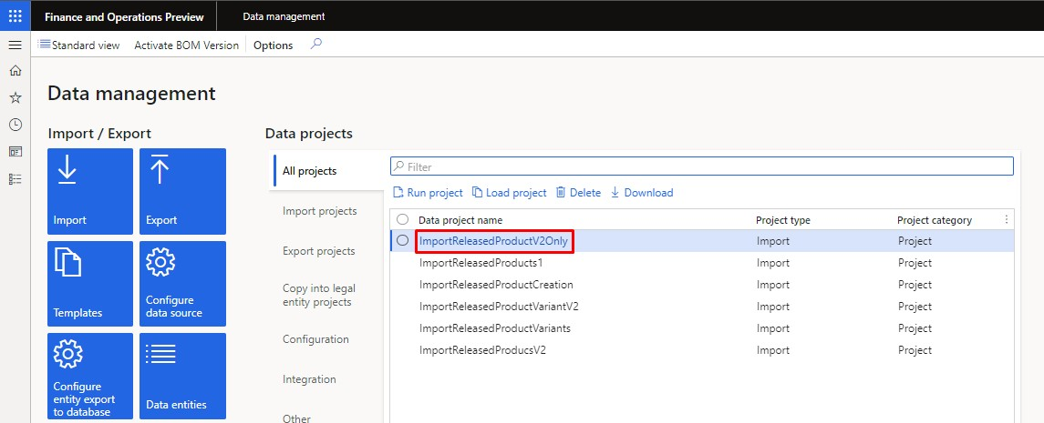

Figure . Import Released Product V2

Go to the Project and select add file”, select “Package” from “Source Data Format”. Click on “Upload and add” button and select the package, which was generated as “Step 2 - Import Released Products V2.zip” at the path specified for output. Now click on “Import in batch” in top-left corner, press OK on the popped-up dialog. Keep checking the process by pressing “Refresh” button. If the process successfully completes a Tick (✓ ) mark is displayed.

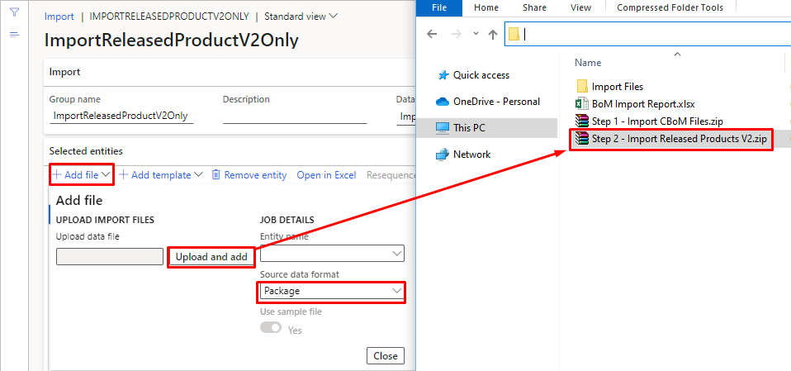

Figure . Upload Released Product V2 File

After Import batch completion, click on the ‘Activate BoM version’ and select the BoM file to upload.

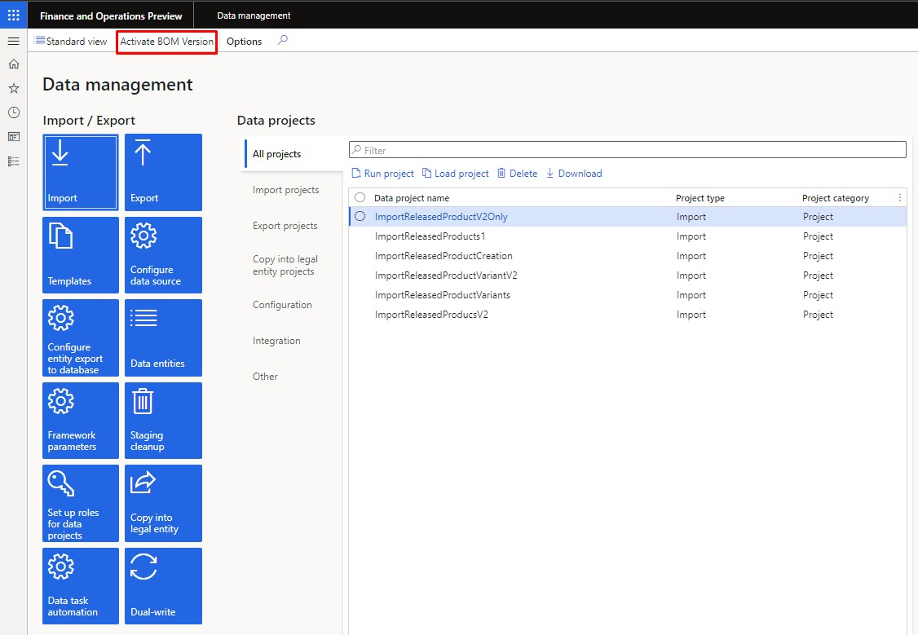

Figure . Activate BoM Version

After clicking on the Browse button, go to the Output folder of generated CBoM files. Open the Import Files folder and go to the ‘Step 3 - Activate BoM Version’. Select the ‘Bill of materials headers and versions V3’ file and upload it.

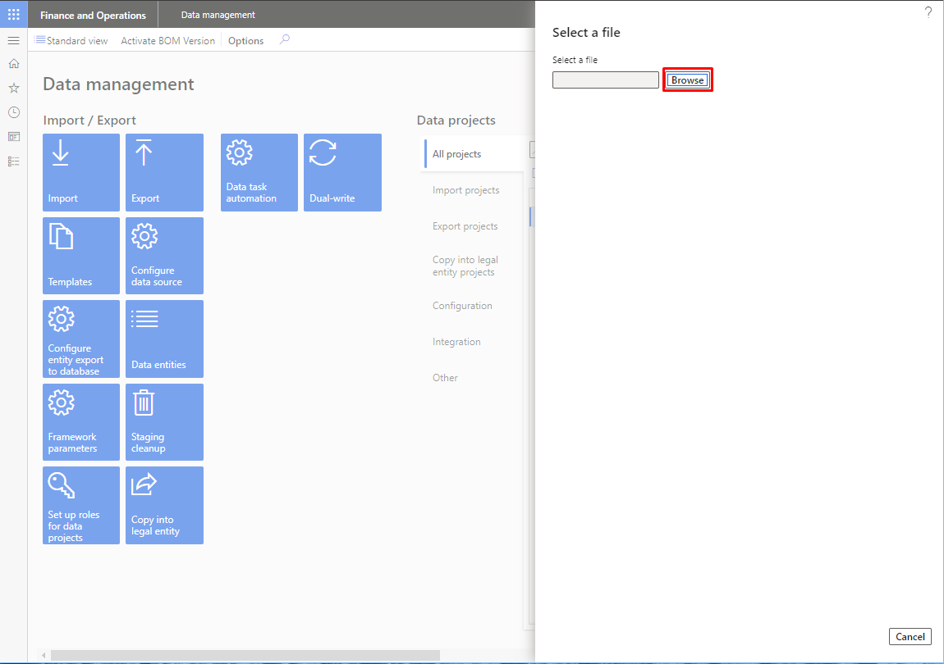

Figure . Activate BoM version process

#### VT Inventory Files

Select this option to update Venturetronics inventory data. Following Inventory files are generated

Approved vendor list by products.xlsx

External item descriptions for vendors V2.xlsx

Inventory counting journal headers.xlsx

Inventory counting journal lines.xlsx

Open purchase price journal lines.xlsx

Product categories.xlsx

Product category assignments.xlsx

Product category hierarchies.xlsx

Product default order settings V3.xlsx

Trade agreement journal table V2.xlsx

VT Inventory Import Report.xlsx

VT Inventory Import Summary.xlsx contains the Updated, Not Updated, Not Found items in Venturetronics inventory. Inventory counting journal headers.xlsx creates new Counting Journal to update the item counting. Inventory counting journal lines.xlsx contains the items whose quantity is changed, and lines are added to create Counting Journal.

Trade agreement journal table V2.xlsx creates new Trade agreement journal in system and Open purchase price journal lines.xlsx contains the Items for whom Trade Agreement needs to be updated. These files are imported to MS Dynamics 365 using Import projects.

To upload the generated inventory files, go to MS Dynamics 365 Data Management module and select “Inventory Import Files” project

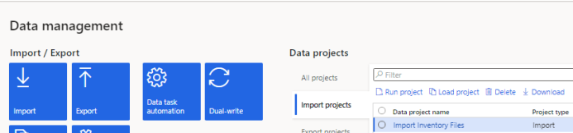

Figure . Inventory Import Files Project

Download the project and replace the package files with the files generated by BoM Import Utility. Click on “Add File” select “Package” from “Source Data Format”. Click on “Upload and add” button and select the package, which was downloaded, and files were replaced as shown similarly in **Figure 25**. Now click on “Import in batch” in top-left corner, press OK on the popped-up dialog and wait for process to complete by clicking the refresh button as shown in **Figure 19** .Keep checking the process by pressing “Refresh” button. If the process successfully completes a Tick (✓ ) mark is displayed as shown in **Figure 20**. Now check the Inventory On-Hand list and verify that Inventory is updated.

#### Jabil Inventory Files

This option provides the facility to generate the data files required to update Jabil Inventory in MS Dynamics365. For this Jabil Inventory sheet is required as input instead of BoM excel file and selection of “Jabil Inventory” radio button in the right side “Select BoM” panel.

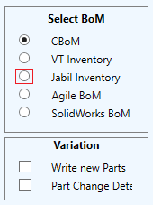

Figure . BoM Import Utility Options

Press the “Generate Invent Files” button and wait for the process to complete. At the completion of file generation all the Application controls are enabled which were disabled at the start of process. Now open the latest generated folder in Output directory. Following files will have been generated in the folder.

Inventory counting journal headers.xlsx

Inventory counting journal lines.xlsx

Jabil Inventory Import Summary.xlsx

Open purchase price journal lines.xlsx

Trade agreement journal table V2.xlsx

Inventory counting journal headers.xlsx and Inventory counting journal lines.xlsx are used to update Jabil Inventory data. Jabil Inventory Import Summary.xlsx contains the Updated, Not Updated, Not Found items in MS Dynamics 365 system. Open purchase price journal lines.xlsx and Trade agreement journal table V2.xlsx are used to update Trade Agreement Journal for Jabil Inventory items.

To upload the generated inventory files, go to MS Dynamics 365 Data Management module and select “Inventory Import Files” project

Download the project and replace the package files with the files generated by BoM Import Utility. Click on “Add File” select “Package” from “Source Data Format”. Click on “Upload and add” button and select the package, which was downloaded, and files were replaced as shown similarly in **Figure 22** . Now click on “Import in batch” in top-left corner, press OK on the popped-up dialog and wait for process to complete. Keep checking the process by pressing “Refresh” button. If the process successfully completes a Tick (✓ ) mark is displayed as shown below. Now check the Inventory On-Hand list and verify that Inventory is updated.



Figure . Files Import Completion

#### Agile BoM

This option is provided to add Parent No and Part No columns to given Agile BoM file from given assembly levels. The columns are added to source file directly. The figures below show the files before and after processing by Utility.

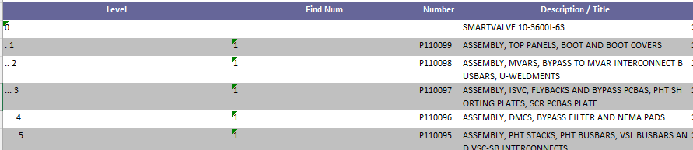

Figure . Agile BoM Before Processing

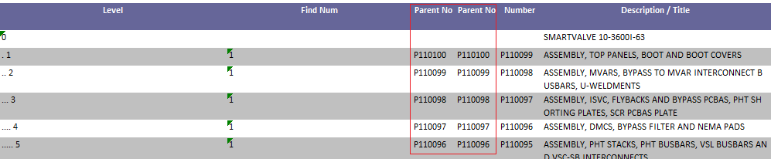

Figure . Agile BoM After Processing

#### Solidworks BoM

This option is provided to process Solidworks BoM and add Parent No and Part No columns to the given file. The Utility also identifies the invalid entries. The figures below show the Solidworks BoM before and after processing by Utility.

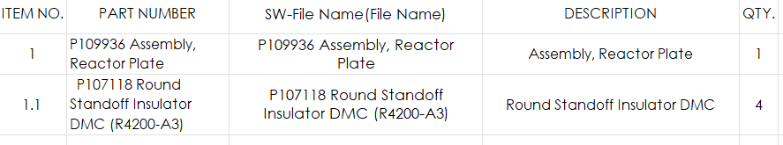

Figure . Solidworks BoM Before Processing

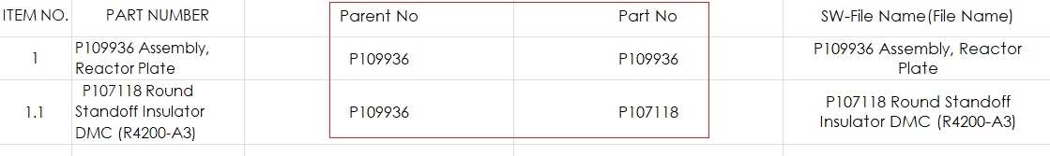

Figure . Solidworks BoM After Processing

#### Write New Parts

Select this option to write only newly added Parts to Released Product Variants file.

#### Part Change Detection

Select this option to get the change report of different Parts. The Utility detects if there is any change in Part Type, Notes or Description.

#### Import Trade Agreement Journal and Category Assignment

Go to MS Dynamics 365 Data Management module an select “Import Trade Agreement Journal and Cat Assignment” project. Click on “Download” as shown below

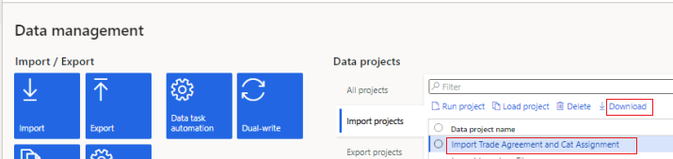

Figure . Trade Agreement Journal Import

Open the downloaded folder and replace the following files from BoM Import Utility Output folder.

Open purchase price journal lines.xlsx

Product categories.xlsx

Product category assignments.xlsx

Trade agreement journal table V2.xlsx

Comeback to MS Dynamics 365 opened Project and click on “Add File”, select “Package” from “Source Data Format”. Click on “Upload and add” button and select the package, which was downloaded, and files were replaced. Now click on “Import in batch” in top-left corner, press OK on the popped-up dialog as shown in **Figure 18** and wait for process to complete as shown in **Figure 19**. Keep checking the process by pressing “Refresh” button. If the process successfully completes a Tick (✓ ) mark is displayed as shown in **Figure 20**. Now check the Inventory On-Hand list and verify that Inventory is updated.

#### Import Approved Vendor List

Go to MS Dynamics 365 Data Management module an select “Import Approved Vendor List” project. Click on “Download” as shown below

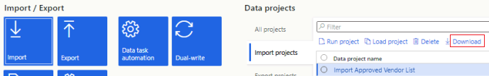

Figure . Approved Vendor List Project

Open the downloaded folder and replace the following files from BoM Import Utility Output folder.

Approved vendor list by products.xlsx

External item descriptions for vendors V2.xlsx

Comeback to MS Dynamics 365 opened Project and click on “Add File”, select “Package” from “Source Data Format”. Click on “Upload and add” button and select the package, which was downloaded, and files were replaced. Now click on “Import in batch” in top-left corner, press OK on the popped-up dialog as shown in **Figure 18** and wait for process to complete as shown in **Figure 19**. Keep checking the process by pressing “Refresh” button. If the process successfully completes a Tick (✓ ) mark is displayed as shown in **Figure 20**. Now check the Inventory On-Hand list and verify that Inventory is updated.